



+

A PROJECT REPORT ON
“BRAIN TUMOR DETECTION USING DEEP LEARNING”
Submitted in partial fulfillment of the requirements for the award of the Degree of

“MASTER OF COMPUTER SCIENCE”

Submitted by
SUDARSHAN D
P06MC23S038004

Under the guidance of
Dr. PRABHAKAR C. J
Professor
Department of P.G Studies and Research in MCA and Computer Science Kuvempu University, Jnana Sahyadri
Shankaraghatta- 577451

2024 – 25

CERTIFICATE

This is to certify that the project entitled “BRAIN TUMOR DETECTION USINFD DEEP LEARNING” submitted by Mr. SUDARSHAN D (P06MC23S038004) student of IV Semester M.Sc. (Computer Science) course under the guidance of Dr. PRABHAKAR C. J., Professor, Department of MCA and Computer Science, for the partial fulfillment of the requirements for the completion of the Degree, MASTER OF COMPUTER SCIENCE, prescribed by the Kuvempu University during the academic year 2024-2025.

Chairman: Under the Guidance
…………………. ………………….
Dr. PRABHAKAR C J Dr. PRABHAKAR C J
Department of MCA and Computer Science Professor Department of MCA and
Computer Science

Date: Signature of the Examiners
Place: Shankaraghatta
1. ………………………
2 ……………………….

DECLARATION

I hereby declare that, the project entitled “BRAIN TUMOR DETECTION USING DEEP LEARNING” submitted to the Department of MCA and Computer Science, has been carried out by under the guidance of Dr. PRABHAKAR C.J. Professor, Department of MCA and Computer Science, Kuvempu University, as the partial fulfillment of the requirements of Master of Computer Science. Further I declare that, this has not been previously formed as the basis for the award of any Degree or Diploma of this or any other University or Institute.

Mr. SUDARSHAN D

Date :
Place : Shankaraghatta

ACKNOWLEDGEMENT

On presenting the project report on “BRAIN TUMOR DETECTION USING DEEP LEARNING” I feel great to express my humble feelings of thanks to all those who have helped me directly or indirectly in the successful presentation of the project.
I would like to thank my beloved guide Dr. PRABHAKAR C.J, Chairman and Professor, Department of MCA & Computer Science, who helped me a lot in presenting this project, for his continuous encouragement and guidance throughout the presentation.
I extend my sincere thanks to Dr. YOGISH NAIK G.R., Associate Professor, Dr. SURESHA M., Associate Professor and Dr. RAVIKUMAR M., Professor, Kuvempu University, Shankaraghatta, for guidance, constant encouragement and valuable suggestion throughout the project.
I would like to thank my parents for their faith and confidence reposed in me and for guiding me on the right path. I also thank all my friends who co-operated with me to the best possible extent.
Finally, I would like to thank the whole Teaching and Non-Teaching Staff of Department of MCA and Computer Science.

Mr. SUDARSHAN D

“BRAIN TUMOR DETECTION USING DEEP LEARNING”

Abstract
Brain tumours are among the most severe and life-threatening neurological disorders, where early and accurate detection plays a crucial role in improving patient prognosis and guiding appropriate treatment plans. Traditional diagnosis through manual interpretation of Magnetic Resonance Imaging (MRI) scans can be time-consuming, subjective, and prone to error due to the complexity and variability of tumour appearances. To address these limitations, this project proposes an automated brain tumour detection system based on deep learning, specifically utilizingVGG 16, to classify MRI images into tumour and non-tumour categories.
The system is implemented using Python with deep learning libraries such as Tensor Flow and Koras. The methodology includes comprehensive stages: image pre-processing, data augmentation, model architecture design, training, validation, and performance evaluation using accuracy, precision, recall, and F1-score metrics. The model is trained on a publicly available MRI dataset, ensuring generalizability and reproducibility. This automated approach significantly reduces diagnostic time, enhances classification accuracy, and serves as a reliable decision-support tool for radiologists. Future extensions of this work may include multi-class tumour classification (e.g., glioma, meningioma, pituitary), 3D MRI analysis, precise tumour region segmentation, and integration into real-time clinical systems via web or mobile applications.

Table of Contents

CHAPTER 1
INTRODUCTION
1.1 Importance of Brain Tumors Detection
1.2 Overview of the Project
1.3 Purpose of the Project
1.4 Scope of the Project
1.5 Problem Statement
1.6 Objective
1.7 Application
1.8 Challenges
1.9 About Deep learning Learning
1.9.1 Working of Deep Learning…………………………………………………………….......

Chapter 2
LITERATURE SURVEY

Chapter 3
METHODOLOGY
3.1 DATASET
3.2 Tools and Technologies Used
3.3 VGG 16 MODEL ARCHITECTURE
3.3.1 Input layer
3.3.2 Convolutional Layers (Feature Extraction)
3.3.3 Max pooling ……………………………………………………………………………..
3.3.4 Flatten Layer……………………………………………………………………………..
3.3.5 Fully Connected (Dense) Layers………………………………………………………
3.3.6 Final Output as Probability……………………………………………………………
CHAPTER 4
4.1 RESULTS AND ANALYSIS
CHAPTER 5
5.1 CONCLUSION AND FUTURE SCOPE
5.1.1 Conclusion
5.1.2 Future Scope
5.1.3 Bibliography

CHAPTER 1

INTRODUCTION
Brain tumor is a lump or mass of abnormal cells that grows in the brain. Normally, the cells in our body grow and divide in a controlled way. But sometimes, certain cells in the brain start to grow too fast or in the wrong way, forming a tumor. There are two main types of tumors malignant (cancerous) tumors and benign (non-cancerous) tumors. These can be further classified as primary tumors, which start within the brain, and secondary tumors

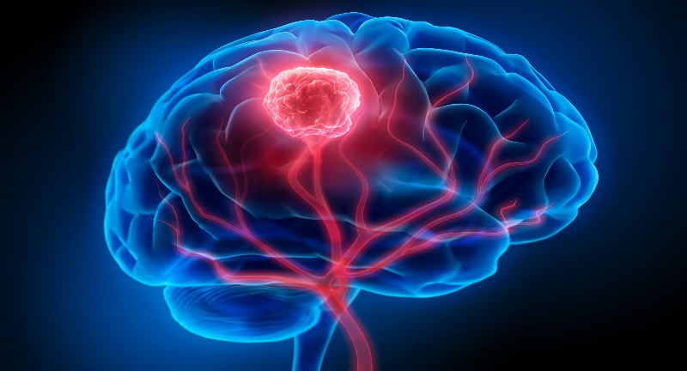
Fig 1: Visualization of a brain tumor highlighted in red within the brain structure.
- Malignant: A malignant brain tumor is a cancerous lump that grows inside the brain. It is made up of abnormal cells that grow very fast and do not stop when they should. These cells can damage healthy brain parts and cause serious health problems. Malignant tumors are more dangerous than non-cancerous (benign) tumors. They can spread to nearby areas of the brain and may come back even after tree.
2. Benign: Benign (non-cancerous) tumors are abnormal masses of cells that grow in a controlled manner and do not invade surrounding tissues or spread to distant parts of the body like cancerous tumors do. They typically grow slowly and have clear, defined edges, making them easier to remove through surgery. Although benign tumors are not life-threatening in most cases, they can still cause health issues if they press on vital organs, nerves, or blood vessels. Common examples include lipomas (fatty growths), fibroids (in the uterus), and adenomas (in glandular tissues). Diagnosis usually involves imaging tests and biopsy to confirm the tumor’s nature.

Primary Brain tumors: A primary brain tumour is a type of tumour that starts in the brain itself and is not caused by cancer spreading from another part of the body. It forms when normal brain cells start to grow abnormally and multiply uncontrollably, creating a lump or mass. Primary brain tumours can be either benign (non-cancerous) or malignant (cancerous). Benign tumours usually grow slowly and may not spread, but they can still be dangerous if they press on important areas of the brain. Malignant tumours grow quickly, can damage nearby brain tissue, and may return even after treatment. Common types of primary brain tumours include gliomas, meningiomas, pituitary adenomas, and medulloblastomas. Symptoms depend on the tumour’s size and location but often include headaches, seizures, vision problems, speech difficulties, and memory loss. Doctor’s use scans like MRI and CT to detect brain tumours, and treatments may involve surgery, radiation, and chemotherapy. Early diagnosis and proper medical care are important for better outcomes.
- Gliomas: Gliomas are one of the most common types of primary brain tumors. They develop from glial cells, which are the supporting cells in the brain. These cells help neurons (nerve cells) by providing structure, nutrients, and protection. When glial cells start to grow abnormally and uncontrollably, they form a tumors called a glioma. Gliomas can be either benign (non-cancerous) or malignant (cancerous), but most gliomas are malignant and grow quickly. These tumors can affect important brain functions like movement, memory, speech, and coordination, depending on where they form.
- Meningiomas: Meningioma’s are a type of primary brain tumors that starts in the meninges, which are the protective layers (membranes) covering the brain and spinal cord. These layers act like a shield, keeping the brain safe inside the skull. When the cells in the meninges start to grow uncontrollably, they form a tumors known as a meningioma. Most meningiomas are benign (non-cancerous), which means they grow slowly and do not spread to other parts of the brain or body. However, some can be atypical (unusual) or malignant (cancerous), which means they may grow faster and can come back even after treatment. Meningiomas are more common in adults, especially in women over the age of 40, and are rare in children.

- Pituitary adenoma: A pituitary adenoma is a type of non-cancerous (benign) brain tumors that grows in the pituitary gland. The pituitary gland is a small, pea-sized gland located at the base of the brain. Even though it is small, it is very important because it controls many of the body’s functions by releasing hormones that regulate growth, metabolism, reproduction, and stress response.
Secondary Tumors: A secondary tumor, also known as a metastatic tumor, is a cancerous growth that has spread from its original (primary) site to another part of the body. This occurs when cancer cells break away from the primary tumor, travel through the bloodstream or lymphatic system, and form new tumors in other organs or tissues

Importance of Brain Tumors Detection

Early and Accurate Diagnosis: Brain tumours can be life-threatening if not detected at an early stage. Traditional diagnosis relies heavily on manual interpretation of MRI scans by radiologists, which can be time-consuming and prone to human error. Deep learning models, particularly Convolutional Neural Networks (CNNs), offer a powerful solution by automatically analyzing MRI images and detecting tumours with high precision. Early and accurate detection using deep learning can significantly improve treatment outcomes and even save lives.
- Automation of Complex Tasks: Deep learning automates the tedious and repetitive task of examining large numbers of MRI images. Unlike manual inspection, which is resource-intensive, deep learning models can process thousands of scans rapidly and consistently. This automation is especially helpful in regions with a shortage of radiologists, improving access to healthcare services and reducing diagnosis delays.

High Accuracy and Reliability: With proper training on large datasets, deep learning models can achieve greater than 95% accuracy in tumour classification. These models are capable of learning minute patterns and differences that may be missed by the human eye. This high reliability makes them ideal as decision support tools in hospitals and clinics, helping doctors confirm or cross-check diagnoses.

Scalability and Accessibility: Once developed and deployed, deep learning-based detection systems can be scaled to hospitals, clinics, and mobile applications globally. This means that even remote or under-resourced areas can benefit from AI-powered.

1.2 Overview of the Project
This project focuses on the automatic detection of brain tumours from MRI (Magnetic Resonance Imaging) scans using VGG16, a pre-trained Convolutional Neural Network (CNN) model. VGG16 was originally developed for large-scale image classification tasks and is known for its simplicity, depth, and accuracy. In this project, we apply transfer learning using VGG16 to efficiently classify MRI images into tumour and non-tumour categories.
The primary goal of this project is to build an intelligent system that can assist radiologists in identifying tumours early, thus reducing diagnostic errors and accelerating the decision-making process. Brain tumours, if not detected early, can lead to life-threatening complications. Manual interpretation of MRI scans is time-consuming and prone to human error, especially when multiple scans must be evaluated. By automating this task, the model can help in high-volume clinical environments or in rural areas with limited access to radiologists.
To achieve this, the original fully connected (dense) layers of VGG16 are replaced with a custom classifier that is specifically trained on brain MRI data. Images are resized to the required 224 x 224 pixels, normalized, and augmented with various techniques such as flipping and rotation to improve the model’s robustness. Only the classifier head is trained, while the base convolutional layers are frozen or fine-tuned as needed. Dropout layers are used to prevent overfitting, and performance is evaluated using metrics such as accuracy, precision, recall, and F1-score.

1.3 Purpose of the Project
The main purpose of this project is to develop an automated system for brain tumour detection using deep learning techniques, specifically the VGG16 model. Brain tumours are a serious medical condition that can become fatal if not detected and treated at an early stage. This project aims to support early and accurate diagnosis by classifying MRI images into tumour and non-tumour categories, thereby assisting doctors in identifying cases that require urgent medical attention.
In many parts of the world, there is a shortage of trained radiologists, especially in rural or underdeveloped areas. Manual analysis of MRI scans is time-consuming and subject to human error. This project helps to overcome these challenges by offering a computer-aided diagnostic system that can quickly analyse MRI images and provide reliable predictions, reducing the workload on medical professionals and improving diagnostic consistency.

1.4 Scope of the Project
The scope of this project includes the design, development, and evaluation of a deep learning-based system for the detection of brain tumours from MRI images using the VGG16 model. The system focuses on binary classification—distinguishing between tumour and non-tumour brain MRI scans. It is limited to 2D MRI image classification and does not currently include 3D image analysis or tumour segmentation, although these can be explored in future enhancements.
The project makes use of a pre-trained CNN model (VGG16) through transfer learning, which significantly reduces the computational resources and training time needed. It also involves data pre-processing, augmentation, model fine-tuning, and performance evaluation using accuracy, precision, recall, and F1-score metrics. The system is tested on publicly available datasets, ensuring that it is generalizable to real-world cases to a reasonable extent.
Moreover, the scope involves a proof of concept for AI-assisted medical diagnosis, aiming to demonstrate how deep learning models can support medical professionals. However, it is not intended to replace clinical decision-making but to function as a supportive diagnostic tool that enhances speed and accuracy in the diagnosis process.

1.5 Problem Statement
Brain tumours are one of the most serious and life-threatening health conditions, requiring early detection for effective treatment. Manual diagnosis of brain tumours using MRI scans is a time-consuming, complex, and error-prone process, often dependent on the expertise and experience of radiologists. In many regions, especially rural and underdeveloped areas, the availability of trained medical professionals and diagnostic facilities is limited, which leads to delays in diagnosis and treatment. These delays can result in the progression of the tumor to more severe stages, drastically reducing the patient's chances of survival.
Medical imaging, particularly MRI, is a powerful tool for diagnosing brain tumours, but analysing these images manually can lead to variability in results, missed detections, and inconsistencies in interpretation. As the volume of medical data increases, the burden on radiologists also grows, increasing the risk of fatigue-related diagnostic errors. This highlights the urgent need for an automated, reliable, and accurate system that can assist in identifying brain tumours at an early stage.
Despite the potential of deep learning technologies, there is still a lack of widely available, practical AI-based diagnostic tools that can accurately classify MRI scans into tumor and non-tumor categories. Many existing models are not optimized for medical imaging or require large, labelled datasets, which are often difficult to obtain in clinical settings.

1.6 Objectives
- To build a brain tumor detection model using deep learning.
- To pre-process the MRI images by removing unwanted data and resizing.
- To use the VGG16 model for model training and classification.
- To evaluate the performance of the proposed model by various performance metrics.
- To create an interface where users can upload an MRI image and get the prediction result.

1.7 Applications
- Early and Accurate Diagnosis: Deep learning models can analyse brain MRI scans with high accuracy, detecting even small and complex tumours. This helps in:
- Reducing human error in diagnosis
- Identifying tumours at an early stage, which is crucial for patient survival
- Classifying tumor types (e.g., glioma, meningioma, pituitary) for proper treatment planning
- Tumour Localization and Segmentation: Convolutional Neural Networks (CNNs) and architectures like U-Net are widely used to segment the exact area of the tumor in MRI scans.
- Helps neurosurgeons plan precise surgical operations
- Minimizes damage to surrounding healthy tissue
- Aids in measuring tumor size and growth over time
- Treatment Planning and Monitoring: Once a tumor is detected, deep learning tools can:
- Predict tumor aggressiveness
- Monitor the response of tumours to chemotherapy or radiation
- Assist doctors in making informed treatment decisions
- Reduction in Diagnosis Time: Automated deep learning systems can scan hundreds of images in seconds, providing quick preliminary reports. This is particularly helpful in:
- Emergency situations
- Hospitals with limited radiology staff

1.8 Challenges
- Need for Early and Accurate Detection: Brain tumors are life-threatening and require early diagnosis for effective treatment. Manual MRI interpretation is time-consuming, error-prone, and highly dependent on the radiologist’s expertise.
- Challenges in Rural and Underdeveloped Areas: Limited access to trained professionals and diagnostic facilities in many regions causes delays in tumor detection, reducing patient survival chances.
- Limitations of Manual MRI Analysis: Manual analysis of MRI scans can lead to inconsistent results, missed detections, and increased diagnostic errors due to radiologist fatigue and growing data volumes.
- Proposed AI-Based Solution: The project proposes a deep learning-based system using a fine-tuned VGG16 model to automate brain tumor classification in MRI scans, aiming to reduce expert dependency and improve diagnosis, especially in low-resource settings.

1.9 About Deep learning
Deep Learning is a cutting-edge branch of Artificial Intelligence (AI) and a subfield of Machine Learning (ML) that focuses on learning from large volumes of data through multi-layered neural networks. These models attempt to mimic the human brain's ability to learn and process information by using artificial neurons, which are connected in structured layers. The main goal of deep learning is to allow a system to learn features and patterns in data automatically, without the need for manual feature extraction.
At the heart of deep learning lies the Artificial Neural Network (ANN). A basic neural network has three types of layers: an input layer, one or more hidden layers, and an output layer. Each neuron receives input, processes it using an activation function, and passes the result to the next layer. As the network grows deeper (more hidden layers), it gains the capacity to understand and represent more abstract and complex patterns. This makes deep learning highly effective for solving tasks like image classification, object detection, speech recognition, machine translation, and medical diagnostics.

1.9.1 Working of Deep Learning
- Inspired by the Human Brain
Deep learning models simulate how the human brain processes information. In biological systems, neurons communicate through synapses, and learning happens as the brain strengthens or weakens these connections. Similarly, deep learning uses artificial neurons arranged in layers. Each neuron receives inputs, processes them, and passes the result to the next neuron. The strength of the connection is determined by weights, which are adjusted during training to improve performance. This neural network structure enables machines to learn abstract patterns and make intelligent decisions.

Layered Architecture
A deep learning model has three major components:
- Input layer: Accepts raw data like images or text.
- Hidden layers: Extract features through mathematical operations and transformations. The deeper the model, the more complex the patterns it can learn (e.g., edges → textures → organs → tumor shapes).
- Output layer: Produces the final result (e.g., classification or prediction).
Each connection between neurons has an associated weight and bias, which are key to how the network learns. Modern deep networks can have dozens to hundreds of layers, making them capable of solving very complex tasks like language translation or tumor detection from MRI scans.

Feature Extraction and Learning
In traditional machine learning, experts must manually extract features (like shape, colour, and size). In deep learning, the model automatically learns features from raw data. For example, when analysing MRI images, the early layers may detect low-level features like edges or brightness, while deeper layers capture complex patterns like abnormal tissue shapes. This automatic hierarchical feature learning is one of the biggest advantages of deep learning over conventional methods. It allows deep learning models to generalize better across different types of input data.

Forward Propagation
During forward propagation, data flows from the input layer to the output layer. Each neuron in the hidden layers:
- Multiplies input values by weights.
- Adds a bias.
- Applies an activation function (e.g., ReLU, tanh, sigmoid) to introduce non-linearity.
This allows the network to learn non-linear relationships in data (e.g., curved shapes in a tumor). The final output could be a class label like “Tumor” or “Non-Tumor” or a probability (e.g., 0.93 confidence for tumor presence).

Backpropagation and Weight Update
After the forward pass, the model calculates how far its prediction is from the actual label using a loss function. This error is then back-propagated through the network. During this backward pass, the model adjusts weights using:
- Partial derivatives of the loss function. Gradient Descent (or other optimizers like Adam).
This iterative process is called learning, where the model continuously updates weights to reduce the error. Over time, the network becomes more accurate and starts making better predictions. This step is crucial for improving model performance over multiple training cycles.

Training and Convergence
Training involves feeding the model a large amount of labelled data and repeating forward and backward passes over multiple epochs. Each epoch means one complete pass through the dataset. With every epoch, the model updates its parameters and gradually improves its accuracy. The process continues until the model reaches convergence, where the loss function stabilizes and validation accuracy stops improving. Proper training also requires techniques like batch normalization, dropout, and early stopping to prevent overfitting and ensure good generalization to unseen data.

Prediction and Inference
Once trained, the deep learning model is ready to make real-world predictions. This stage is called inference. For example, in a brain tumor detection system, a new MRI scan is input into the model, and it outputs whether a tumor is present and how confident it is. These predictions are fast and efficient, making them ideal for real-time decision-making in hospitals or diagnostic labs. Moreover, the model can be deployed on cloud servers, mobile apps, or hospital systems to assist doctors during diagnosis.

Chapter 2

2. LITERATURE SURVEY

Several research papers were reviewed and analyzed to understand the existing methodologies in brain tumor detection. Based on insights gathered from these studies, a deep learning model was developed. All the referenced papers have been cited and acknowledged in this work.
1. Brain tumor detection and classification using machine learning: a comprehensive survey [1]
The paper "Brain Tumor Detection and Classification Using Machine Learning: A Comprehensive Survey" by Javaria Amin et al. (2021) provides a detailed overview of techniques used to detect and classify brain tumors using MRI data. It explores both machine learning methods, such as SVM and k-NN, and deep learning techniques like CNNs and transfer learning. The authors discuss key steps in the detection pipeline, including preprocessing, image enhancement, segmentation, and feature extraction. Publicly available datasets and their role in research are also covered. The survey emphasizes the growing importance of AI in medical imaging for brain tumor analysis and classification.

2. Ensemble of Deep Learning Models for Brain Tumor Detection [2]

Authors: S. Patil and D. Ki range
The study used T1-weighted contrast-enhanced (T1C) MRI images consisting of approximately 3064 scans categorized into three tumor types: glioma, meningioma, and pituitary tumor. Two deep learning models were implemented—a custom 9-layer Shallow Convolutional Neural Network (SCNN) to extract shallow features, and a pre-trained VGG16 model fine-tuned on the same dataset to extract deeper features. Features from both models were fused into a single feature vector, which was then passed through a fully connected neural network for final classification. This ensemble model, named Ensemble Deep Convolutional Neural Network (EDCNN), was trained and evaluated using performance metrics such as accuracy and loss.

3. Brain Tumor Detection and Segmentation in MR Images Using Deep Learning [3]

The study titled "Brain Tumor Detection and Segmentation in MR Images Using Deep Learning", published on Research Gate around 2018–2019, focuses on the segmentation of glioma tumors using a deep learning-based hybrid Convolutional Neural Network (CNN) model. It utilizes the BRATS 2013 dataset with multimodal MRI modalities including T1, T1C, T2, and FLAIR. The approach follows a patch-based strategy and incorporates techniques like dropout regularization, batch normalization, and a two-phase training process to address overfitting and class imbalance. The preprocessing pipeline involves intensity normalization and bias field correction, while post-processing removes small false positives near the skull region.

4. Design and Implementing Brain Tumor Detection Using Machine Learning Approach [4]
Authors: Sonia Paul, Brines Kumar Soni, and B. Baranidharan
This research proposes an automatic CNN-based method for detecting and segmenting brain tumors from MRI scans, focusing on achieving accurate classification in both automatic and semi-automatic contexts. The approach involves six stages: data collection, pre-processing, average filtering, segmentation, feature extraction, and classification using a CNN with 3×3 convolutional kernels. Data mining techniques are leveraged to discover meaningful patterns and correlations in healthcare data. The convolutional network architecture reliably processes segmented tumor regions via small kernel operations across layers. Overall, this integration of data mining and CNN-based machine learning is designed for early detection and precise identification of brain tumors in MRI images.
5. Intelligent Model for Brain Tumor Identification Using Deep Learning [5]
Authors: Abdul Hanna Khan, Sagheer Abbas, Muhammad Adnan Khan, Umar Farooq, Waseem Ahmad Khan, Shahan Yamen Siddiqui, Aisha Ahmad
This study presents a deep learning-based intelligent model for automatic detection and classification of brain tumors using MRI images. It introduces a hierarchical convolutional neural network (CNN) architecture that classifies brain tumors into four categories: glioma, meningioma, pituitary, and no tumor. The system is designed to support physicians by reducing diagnostic dependency on manual image interpretation and enabling early and efficient tumor classification. Medical image segmentation and CNN-based feature extraction are used to automate the identification process. The model processes image fragments and applies a multi-level classification approach for improved

6. Detection of Brain Tumor Using Deep Learning [6]

Authors: Hamza Rafi Almadhoun and Sammy S. Abu-Nasser

This research explores the application of deep learning to assist in the detection of brain tumors using MRI scans. The authors developed a computer-based system capable of automatically analyzing brain images to determine the presence or absence of tumors. A dataset consisting of 10,000 MRI images was used to train multiple deep learning models, including VGG16, ResNet50, Mobile Net, InceptionV3, and a custom-designed model. These models were trained to recognize and learn patterns in the images, enabling them to perform binary classification—distinguishing between tumor and non-tumor cases. The study aims to support medical professionals in making faster and more consistent diagnostic decisions.

7. Accurate brain tumors detection using deep convolutional neural network [7]

Authors: Samika Basu, Souvik Kundu, Man tosh Mandal
This paper introduces a deep learning-based method for brain tumor detection and classification using MRI scans. It presents two models: a 23-layer Convolutional Neural Network (CNN) designed for use with a large MRI dataset, and a hybrid model that integrates VGG16 with a custom CNN to address overfitting when working with smaller datasets. The models are structured to handle both binary classification (normal vs. abnormal) and multi-class classification (glioma, meningioma, and pituitary tumors). The approach emphasizes reducing radiologists' manual workload by automating tumor analysis. Additionally, the authors have made their dataset and source code publicly available for further research.

8. Brain tumors detection using statistical and machine learning method [8]
Authors: Naresh Birder, Deepak Kharade, Rahul Deore, V. G. Kharat
The study titled “Brain Tumors Detection Using Statistical and Machine Learning Method” focuses on early detection of brain tumors by combining image processing and machine learning. MRI images are first pre-processed using Wiener filtering and wavelet transforms. Tumour segmentation is performed using Potential Field clustering, thresholding, and morphological operations, especially in FLAIR and T2 modalities. Features are extracted using Local Binary Pattern and Gabor Wavelet Transform, then fused for classification. This method is tested on local and BRATS datasets, achieving high segmentation and classification accuracy. The approach supports radiologists in detecting tumors efficiently and accurately, improving early diagnosis and patient outcomes.
9. Brain Tumour Detection Using Deep Learning Models [9]
The paper discusses the application of deep learning techniques for the detection of brain tumors using MRI scans. It emphasizes the importance of early detection due to the complexity and variability of brain tumors, which can be either benign or malignant. With the advancement of artificial intelligence, deep learning models such as Convolutional Neural Networks (CNN) and VGG-16 are employed to analyse brain MRI images. The study uses a dataset comprising 253 patient MRI scans, categorized into tumorous and non-tumorous cases. The paper aims to compare the effectiveness of CNN and VGG-16 architectures in identifying tumor regions, thereby supporting medical professionals in diagnosis.

10. Brain tumours detection using fusion of hand crafted and deep learning features [10]
The paper titled “Brain Tumours Detection Using Fusion of Hand-Crafted and Deep Learning Features” presents a hybrid approach for early and accurate brain tumor diagnosis. It begins by segmenting MRI images using the Grab Cut algorithm to isolate the tumor region. Deep features are extracted using a fine-tuned VGG-19 model via transfer learning, while hand-crafted features like shape and texture are also computed. These features are fused serially and optimized using entropy to enhance classification speed and precision. The final fused feature set is used for classification, with the model evaluated

Chapter 3

3.METHODOLOGY

3.3 VGG16 MODEL ARCHITECTURE

VGG-16
VGG-16 is a Convolutional Neural Network (CNN) model proposed by the Visual Geometry Group (VGG) at the University of Oxford. It is one of the most famous deep learning models used for image classification and transfer learning. The "16" refers to the 16 weight layers in the network (13 convolutional layers + 3 fully connected layers).

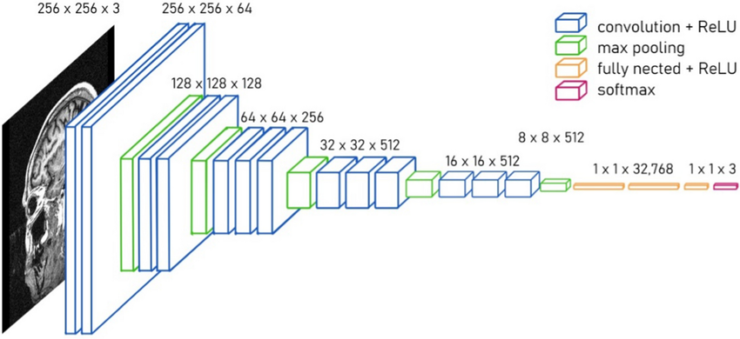
Fig.4 VGG 16 Model architecture
3.3.1 Input layer
The input layer in the VGG-16 architecture serves as the initial stage where the image data is introduced into the neural network. In the original VGG-16 model, this layer is designed to accept images of fixed dimensions — specifically 224 × 224 pixels in height and width, with 3 color channels (RGB). This format matches the requirements of the pertained model, which was originally trained on the ImageNet dataset using color images.
However, in medical imaging applications such as brain tumor detection, MRI scans are typically in grayscale, meaning they have only one channel instead of three. To make these images compatible with VGG-16, grayscale images are either converted to three channels by replicating the single channel across the R, G, and B channels, or the architecture is slightly adjusted. In most implementations, the input image is resized to 224×224 pixels and converted to a 3-channel format to fit the standard VGG-16 input structure.
Before feeding MRI images into the model, several preprocessing steps are performed to enhance performance. These include resizing the image to 224×224, normalizing pixel values to a range of 0–1, and reshaping the image to include a batch dimension. For example, a single image of shape (224, 224, 3) is converted to (1, 224, 224, 3), where '1' indicates the batch size.

3.3.2 Convolutional Layers (Feature Extraction)

Block 1: Conv3-64: The first block in the VGG-16 architecture consists of two convolutional layers, each with 64 filters of size 3×3. These layers process the raw pixel data from the input image and begin learning basic features such as edges, lines, and corners. The convolution operation involves sliding the filter (or kernel) across the image and performing element-wise multiplication and summation, which highlights certain visual patterns. After the convolution, the ReLU (Rectified Linear Unit) activation function is applied to introduce non-linearity, enabling the model to learn complex patterns. The output of the convolutional operations in Block 1 is a feature map of size 224×224×64, where each of the 64 filters captures a different basic feature. This is followed by a Max Pooling layer with a pool size of 2×2 and a stride of 2, which reduces the spatial dimensions by half, resulting in an output of 112×112×64. MaxPooling retains the most important features while reducing computation and overfitting.

Block 2: Conv3-128: The second block continues feature extraction by applying two convolutional layers, now with 128 filters of size 3×3. These layers take the output of Block 1 and build on the previously detected edges and textures to identify more complex patterns, such as curves, corners, and basic shapes. Again, ReLU activation is applied after each convolutional layer to maintain non-linearity. The resulting output is a feature map of 112×112×128, capturing more detailed structural information from the MRI image. A MaxPooling layer is again used to down sample the spatial resolution, resulting in a 56×56×128 output. This operation reduces data size and helps the model focus on the most dominant patterns in each region.

Block 3: Conv3-256: Block 3 is deeper and includes three convolutional layers, each with 256 filters. These layers take in the 56×56×128 feature maps and extract medium-level features, such as tumor boundaries, textures, and irregular tissue formations. With each convolution, the network learns more about the spatial layout and intensity variations common in tumor-affected brain tissues. The repeated application of convolution and ReLU leads to an output of 56×56×256, followed by another MaxPooling layer that reduces the spatial dimensions to 28×28×256. The increased number of filters allows the network to learn more diverse patterns that are essential for distinguishing between tumor and healthy tissues.

Block 4: Conv3-512: In this block, there are three convolutional layers with 512 filters. These layers now extract high-level features that help differentiate between fine-grained tumor characteristics — such as size, shape, and intensity variations. These layers are crucial for medical imaging tasks because they learn complex representations that might not be visible to the naked eye. After passing through the convolution and activation steps, the output remains at 28×28×512, which is then passed through a MaxPooling layer to become 14×14×512. At this stage, the network understands tumor-specific patterns and has created feature maps that strongly represent regions of interest in the MRI scan.

Block 5: Conv3-512: The fifth and final convolutional block mirrors Block 4 and also contains three convolutional layers with 512 filters each. These layers continue to refine the high-level features and focus on very specific tumor traits, such as subtle texture differences, location, and internal structure. These are the most abstract representations and are deeply embedded within the spatial features of the MRI scan. After the convolutions and ReLU activations, the feature map remains 14×14×512. A final MaxPooling layer brings it down to 7×7×512. This low-resolution yet highly descriptive representation is then flattened and sent to the fully connected layers for classification.

3.3.3 Max Pooling
Max Pooling is a crucial operation used in Convolutional Neural Networks (CNNs) to reduce the spatial dimensions of feature maps while preserving the most important information. In simple terms, it looks at small sections of the image (usually 2×2 regions) and keeps only the highest value from each section. This helps the model retain the strongest features, such as edges or bright regions that could indicate the presence of a tumor, while discarding less important details.
In the VGG-16 architecture, Max Pooling is applied after every block of convolutional layers. Each pooling operation reduces the width and height of the feature map by half, which significantly lowers the number of computations required in the deeper layers of the network. For example, after the first convolutional block, the feature map size is reduced from 224×224 to 112×112. This pattern continues across all five blocks, eventually resulting in a compact representation of size 7×7 at the deepest layer.

3.3.4 Flatten Layer
The Flatten layer in the VGG-16 architecture serves as a bridge between the convolutional (feature extraction) part of the network and the fully connected (classification) part. After the final block of convolutional and pooling layers in VGG-16, the output is a 3D tensor of size 7×7×512. This three-dimensional structure cannot be directly passed into dense (fully connected) layers, which require a 1D vector as input. Therefore, the Flatten layer plays the critical role of converting this 3D output into a 1D array, preparing the data for final classification.
Flattening works by taking all the values in the 3D volume (i.e., 7 × 7 × 512 = 25,088 values) and reshaping them into a single row vector of size 25,088 × 1. Each value in this vector represents a feature that was learned from the original image — including patterns, textures, edges, and other characteristics — which are now abstracted and condensed by the earlier convolutional layers. This dense feature vector becomes the input to the fully connected layers, which act like a traditional neural network classifier.

3.3.5 Fully Connected (Dense) Layers

Flattened Input to Dense Layers: Before reaching the fully connected layers, the image has already passed through several convolutional and pooling layers, resulting in a highly refined feature map. In VGG-16, the last pooling layer gives an output of shape 7×7×512. This output is flattened into a single 1D vector of size 25,088 (7 × 7 × 512). This flattened vector contains all the spatial and feature information extracted from the image and serves as the input to the dense layers.

First Fully Connected Layer (FC1): The first dense layer is designed with 4,096 neurons. Each neuron receives input from all 25,088 features from the flattened layer. This creates a dense web of connections, where the model starts learning how various features relate globally. For example, it might relate edge patterns found in different brain regions to form a more complete understanding of tumor shape. A ReLU activation function is used here to introduce non-linearity, enabling the network to model complex relationships beyond simple linear combinations.

Dropout for Regularization: Due to the large number of parameters (each neuron has its own weights), dense layers are prone to overfitting, especially on smaller medical datasets like brain MRIs. To address this, a Dropout layer is typically applied after the first dense layer during training. This layer randomly disables a certain percentage of neurons (commonly 50%) in each training iteration, which forces the network to learn redundant paths and prevents it from becoming too reliant on specific neurons. As a result, the model becomes more generalizable.

Second Fully Connected Layer (FC2): The second dense layer also has 4,096 neurons. It continues to learn from the abstracted features output by the first dense layer. While the first dense layer captures more generic global patterns, the second one focuses on fine-tuning these patterns, refining the features specifically relevant to brain tumor identification. For instance, it may learn subtle differences in texture or shape that distinguish a tumor from healthy tissue. Again, ReLU activation is applied to ensure non-linearity and avoid vanishing gradients.

Dropout Layer (Optional): Similar to the first dropout, a second Dropout layer can be placed here as well. This is especially helpful if the model still shows signs of overfitting. By disabling more neurons randomly during training, it improves the model’s ability to handle variability in MRI scans, such as differences in brightness, contrast, or patient anatomy.

3.3.6 Final Fully Connected (Output) Layer
The last dense layer acts as the output layer, where the number of neurons depends on the classification objective:
- For binary classification (e.g., Tumor vs. No Tumor): Use 1 neuron with a sigmoid activation function, which outputs a probability between 0 and 1.
- For multi-class classification (e.g., Glioma, Meningioma, and Pituitary): Use 3 neurons with Softmax activation, which gives a probability distribution across classes.
This layer directly determines the final prediction by combining all the learned features into a decision. The output layer generates a probability score for each class:
- If using Sigmoid, a result > 0.5 might indicate tumor presence.
- If using Softmax, the class with the highest probability is selected as the prediction.

3.1 DATASET
The Brain Tumour MRI Dataset is a collection of 7,023 human brain MRI images aimed at supporting research and development in brain tumor detection and classification. The dataset is composed by merging three different sources: the Fig share dataset, the SARTAJ dataset, and the Br35H dataset.
- The Fig share dataset is a large, well-annotated set of MRI images covering three tumor types, widely used in research
- The SARTAJ dataset is another public dataset with similar categories but has had issues with labelling accuracy, particularly for glioma images
- The Br35H dataset provides healthy brain MRI images for the "no tumour" class, ensuring balanced and comprehensive datasets for machine learning tasks
The images in this dataset are categorized into four classes: glioma, meningioma, pituitary, and no tumour
Here is the image count for each folder (class) in the Brain Tumour MRI Dataset.
Table 1: MRI Brain Tumor Dataset Overview
Class | Number of Images
Glioma | 1,926
Meningioma | 1,937
Pituitary | 2,075
No Tumour | 710
Total | 7023
Sample MRI Images of Different Brain Tumor Types and Normal Case
X`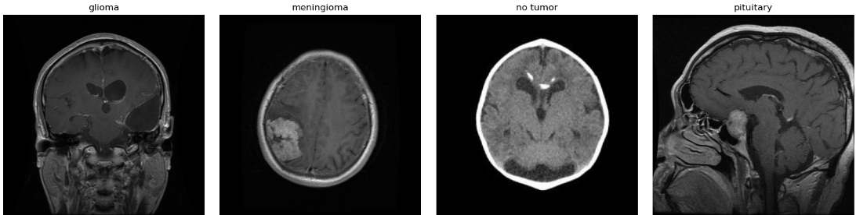 Fig. 2: Sample MRI Images of Different Brain Tumor Types and Normal Case
Manual class Balance:
In the original Brain Tumour MRI dataset, there was a noticeable class imbalance, with the number of images varying significantly between the four categories: glioma, meningioma, pituitary, and no tumour. To ensure fair and unbiased training of machine learning models, I manually balanced the dataset by selecting an equal number of images from each class. Specifically, I curated 710 images for each category, resulting in a balanced dataset where each class is equally represented. This approach helps prevent the model from becoming biased towards any particular class and improves the reliability and generalizability of the classification results. All selected images were stored in their respective class folders, ensuring consistency and clarity in the dataset structure for subsequent analysis and model development.

Table 2. Manual class Balance Dataset
Class | Number of Images
Glioma | 710
Meningioma | 710
Pituitary | 710
No Tumour | 710
Total | 2840

AUGMENTATION:
Table 3: Data Augmentation Techniques Used for MRI Images
S.No. | Augmentation Technique | Description | Mathematical Transformation / Formula
1 | Original | The original input image (no transformation). | Identity transformation:  I′(x,y)=I(x,y)
2 | Rotate +25° | Rotates the image 25 degrees clockwise. | Rotation Matrix:  R($∅)=\begin{matrix}cosθ & -sinθ \\ sinθ & cosθ\end{matrix}$  Apply (x′,y′)=R(25∘)⋅(x,y)(x', y')
3 | Rotate -25° | Rotates the image 25 degrees counter-clockwise. | Same formula as above but with −25∘
4 |  | Flips the image horizontally (left ↔ right). | Flip along vertical axis: I′(x,y)=I(w−x−1,y)  (where w is image width)
  Horizontal Flip
5 | Vertical Flip | Flips the image vertically (top ↔ bottom). | Flip along horizontal axis: I′(x,y)=I(x,h−y−1)  (where h is image height)
6 | Zoom In | Zooms into the centre of the image (crop and rescale). | Crop canter region and rescale: I′=resize(I[x1:x2,y1:y2])  with zoom factor z∈[1,zmax]
7 | Width Shift | Shifts the image left/right by a fraction of the width. | Translate horizontally:  x′=x+(w_shift×W)
8 | Height Shift | Shifts the image up/down | y′=y+(h_shift×H)
Data Augmentation Techniques Applied to MRI Images
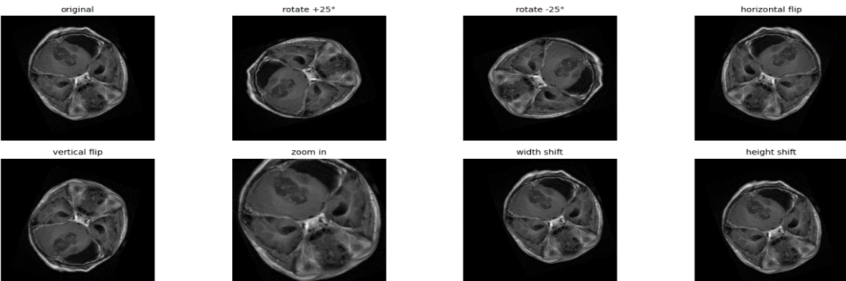
Fig. 3 Data Augmentation Techniques Applied to MRI Image

3.2 Tools and Technologies Used
Programming Language: Python
Deep Learning Framework: Tensor Flow / Koras / PyTorch
Libraries: NumPy, OpenCV, Matplotlib, Pandas, Siket-learn
IDE: Jupyter Notebook / Google Colab
GPU Support: (Optional) Used Google Colab for faster model train in

CHAPTER 4

4. RESULTS AND ANALYSIS
Train the model
The image displays the terminal output of a Keras-based deep learning model during training over 15 epochs. It tracks metrics such as training accuracy, loss, validation accuracy, and validation loss. The model improves progressively, and checkpoints are saved whenever the validation accuracy increases. Messages like "val_accuracy improved" indicate performance gains, while others note when no further improvement is observed. The model is being saved in the legacy HDF5 format (.h5), which triggers a warning suggesting the use of the newer .Keras format. Additional warnings relate to dataset handling and input structure, highlighting best practices and potential compatibility issues during training.
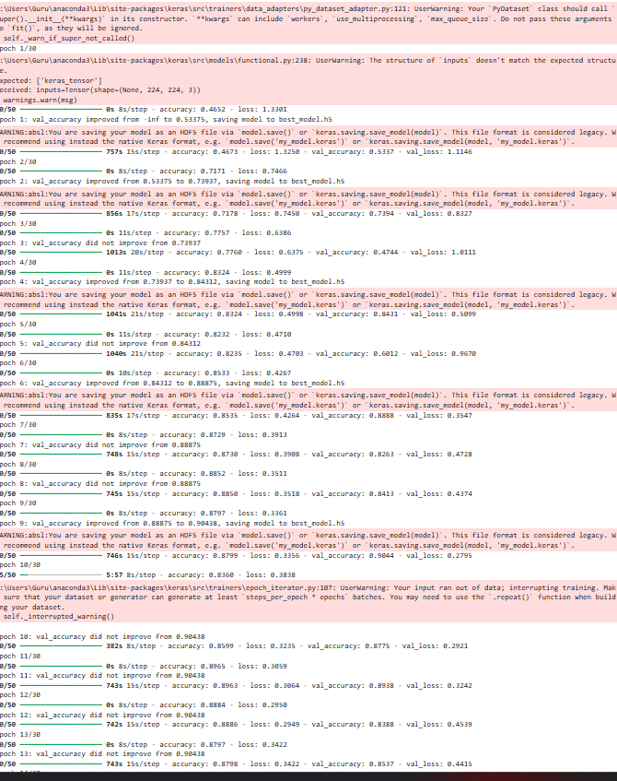
Fig. 5: Training Progress of Brain Tumor Detection Model

Training vs Validation Accuracy
This graph compares training and validation accuracy over 13 epochs in a deep learning model. The blue line represents training accuracy, which steadily increases and stabilizes above 0.9, indicating the model is learning well. The orange line shows validation accuracy, which fluctuates more but generally follows the upward trend of training accuracy. Some sharp drops and rises suggest overfitting risks or small validation data. Despite fluctuations, both accuracies converge toward the end, suggesting good model generalization. The closeness of the two curves in later epochs reflects strong training performance with acceptable validation stability, showing the model is not heavily overfitting.
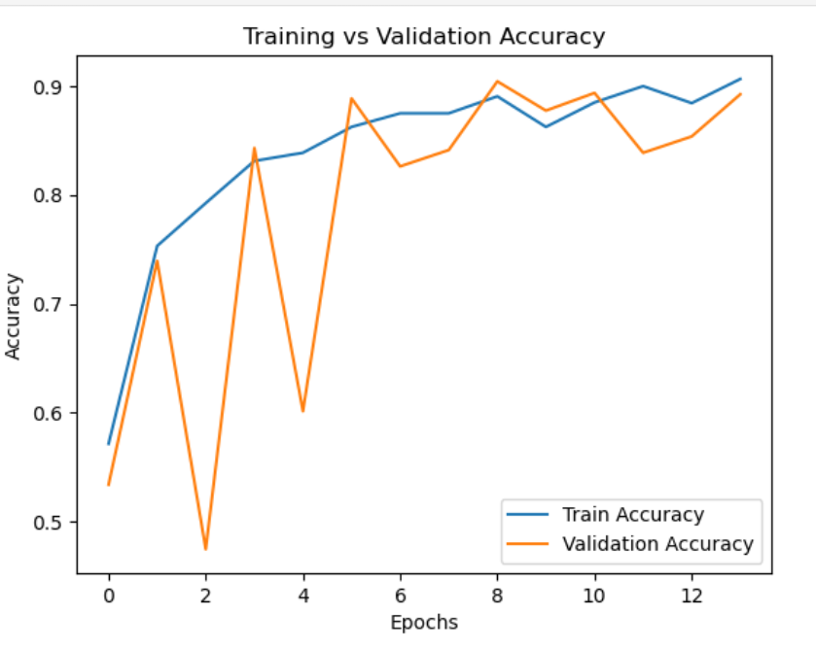
FiG.6 Training vs Validation Accuracy
Loss VS Validation Loss
This graph shows the comparison between training loss (blue line) and validation loss (red line) over 13 epochs. Both losses decrease significantly, indicating effective learning by the model. The training loss fluctuates more, especially in early epochs, possibly due to mini-batch variations. In contrast, validation loss steadily declines and stabilizes, with minimal fluctuations. By the end, both losses converge around 0.3, which suggests the model is generalizing well without overfitting. The overall downward trend in both curves confirms successful optimization, and the close alignment between them in later epochs demonstrates consistent model performance on unseen validation data
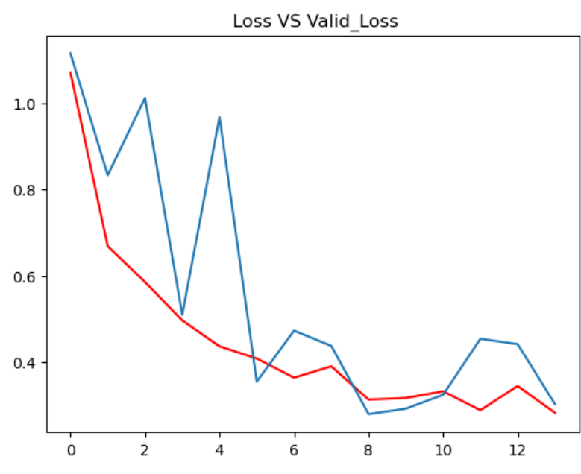
Fig.7 Loss VS Validation Loss
CONFUSION MATRIX:
Confusion matrix is a simple table used to measure how well a classification model is performing. It compares the predictions made by the model with the actual results and shows where the model was right or wrong. This helps you understand where the model is making mistakes so you can improve it. It breaks down the predictions into four categories:
•True Positive (TP): The model correctly predicted a positive outcome i.e. the actual outcome was positive.
•True Negative (TN): The model correctly predicted a negative outcome i.e. the actual outcome was negative.
•False Positive (FP): The model incorrectly predicted a positive outcome i.e. the actual outcome was negative. It is also known as a Type I error.
•False Negative (FN): The model incorrectly predicted a negative outcome i.e. the actual outcome was positive. It is also known as a Type II error.
This confusion matrix is a performance evaluation for an oral cancer classification model. It compares the actual classes (rows) with the predicted classes (columns).

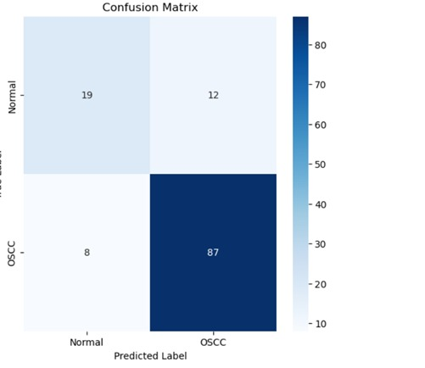
Fig 8.Confusion matrix

Accuracy

Accuracy shows how many predictions the model got right out of all the predictions. It gives idea of overall performance but it can be misleading when one class is more dominant over the other. It can be calculated using the below formula:
Accuracy=$\frac{TP+TN}{TP+TN+FP+FN}$

Precision

Precision focus on the quality of the model’s positive predictions. It tells us how many of the "positive" predictions were actually correct. The formula of precision is:
Precision=$\frac{TP}{TP+FP}$

Recall
Recall measures how good the model is at predicting positives. It shows the proportion of true positives detected out of all the actual positive instances. High recall is essential when missing positive cases has significant consequences like in medical tests.
Recall=$\frac{TP}{TP+FN}$

F1-Score
F1-score combines precision and recall into a single metric to balance their trade-off. It provides a better sense of a model’s overall performance particularly for imbalanced datasets.
$$\frac{2.Precision.Recall}{Precision+Recall}$$
Table 4: Classification Method
 | precision | recall | F1-score | support
normal | 0.70 | 0.61 | 0.66 | 31
Tumor | 0.88 | 0.92 | 0.90 | 95
accuracy |  |  | 0.84 | 126
Macro avg | 0.79 | 0.76 | 0,.78 | 126
Weighted avg | 0.84 | 0.84 | 0.84 | 126
Web Interface for Brain Tumor Detection System:
The user interface of the Brain Tumor Detector web application. It allows users to upload MRI images for analysis. The interface includes a file upload button and an area where the selected image or prediction result is displayed. The application runs on a local server (127.0.0.1:5000) using a Flask backend, which processes the uploaded MRI images using a trained deep learning model to detect the presence of brain tumors.

Fig. 8: Web Interface for Brain Tumor Detection System
Output Interface Indicating No Brain Tumor Detected: The result generated by the Brain Tumor Detector application after an MRI image has been uploaded. The system successfully processes the input and confirms the absence of a brain tumor. A green message stating “No Brain Tumor Detected” is shown along with a visual thumbs-up emoji to indicate a positive result. The interface runs locally using a Flask web server.

Fig. 9: Output Interface Indicating No Brain Tumor Detected
Output Interface Indicating Brain Tumor Detected: the Brain Tumor Detector application when a brain tumor is identified in the uploaded MRI image. After successful image upload, the system processes the input using a deep learning model and displays a red alert message—"Brain Tumor Detected"—along with a sad emoji to visually represent the critical nature of the diagnosis. This interface helps users easily interpret the model’s prediction.


Fig. 10: Output Interface Indicating Brain Tumor Detected

CHAPTER 5

5. CONCLUSION AND FUTURE SCOPE

5.1 Conclusion
In this project, a deep learning-based system was developed to detect brain tumors from MRI images using Convolutional Neural Networks (CNN). The implementation involved key stages such as data pre-processing, model design, training, evaluation, and prediction. The model achieved satisfactory accuracy and was able to classify MRI images into tumor and non-tumor categories effectively. The use of deep learning significantly improved the speed and accuracy of diagnosis, providing a reliable tool to assist medical professionals in early detection and treatment planning.
The results demonstrate that deep learning techniques, especially CNNs, can extract complex features from medical images and provide high-performance classification without the need for manual feature engineering. This automated approach not only reduces human error but also enhances decision-making in clinical settings.

5.1.2 Future Scope
While the current system shows promising results, there are several directions for future enhancements:
- Multiclass Classification:
Extend the model to classify different types of brain tumors (e.g., glioma, meningioma, pituitary tumor) rather than binary classification.
- Tumor Segmentation:
Incorporate advanced architectures like U-Net or Mask R-CNN for pixel-wise tumor segmentation, helping in estimating the size and location of tumors precisely.
- Larger and Diverse Datasets:
Training the model on more diverse and larger datasets will improve its generalization ability across different patient profiles, MRI machines, and clinical conditions.

Bibliography
[1] Amin, J., Sharif, M., Haldorai, A. K., Yasmin, M., & Nayak, R. S. (2021). Brain tumor detection and classification using machine learning: A comprehensive survey. Complex & Intelligent Systems, 8(4), 3161–3183. https://doi.org/10.1007/s40747-021-00563-y
[2] Patil, S., & Ki range, D. (2021). Ensemble of Deep Learning Models for Brain Tumor Detection. International Journal of Engineering Research & Technology (IJERT), 10(06)
[3] Brain Tumor Detection and Segmentation in MR Images Using Deep Learning. (2018). Research Gate. Retrieved from https://www.researchgate.net/publication/330760087
[4] Paul, S., Soni, B. K., & Baranidharan, B. (2021). Design and Implementing Brain Tumor Detection Using Machine Learning Approach. International Journal of Engineering Research & Technology (IJERT), 10(05)
[5] Khan, A. H., Abbas, S., Khan, M. A., Farooq, U., Khan, W. A., Siddiqui, S. Y., & Ahmad, A. (2022). Intelligent Model for Brain Tumor Identification Using Deep Learning. Computational and Mathematical Methods in Medicine, 2022, Article ID 3949563.
[6] Almadhoun, H. R., & Abu-Nasser, S. S. (2021). Detection of Brain Tumor Using Deep Learning. International Journal of Academic Engineering Research (IJAER).
[7] Basu, S., Kundu, S., & Mandal, M. (2020). Accurate Brain Tumors Detection Using Deep Convolutional Neural Network. International Journal of Computer Applications,
[8] Birder, N., Kharade, D., Deore, R., & Kharat, V. G. (2019). Brain Tumors Detection Using Statistical and Machine Learning Method. International Research Journal of Engineering and Technology (IRJET), 6(4), 2316–2321.
[9] Brain Tumour Detection Using Deep Learning Models. International Journal of Innovative Science and Research Technology (IJISRT), 6(5), 2021.
[10] Brain Tumours Detection Using Fusion of Hand-Crafted and Deep Learning Features. International Journal of Imaging Systems and Technology, 31(4), 2021.

